**Experiment Name#02:** Basic Linux Command.

**Aim and Objectives:** The purpose of this lab is to provide how to learn basic Linux command with Linux mint operating system.

**Command:**

1. **whoami :** It shows who logged on this system.

**Basic syntax:** whoami

**Output:**

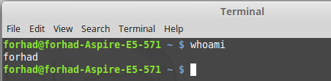

1. **hostname:** It tells on which machine you are.

**Basic syntax:** hostname

**Output:**

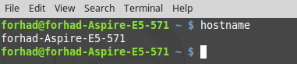

1. **pwd:** It shows the path of current working director.

**Basic syntax:** pwd

**Output:**

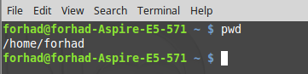

1. **cd :** It brings us to the highest level of your home directory of computer

**Basic syntax:** cd

**Output:**

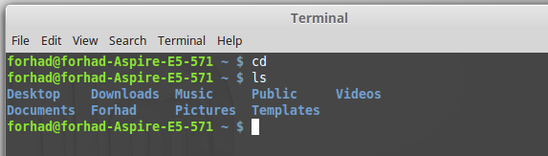

1. **cd .. :** It moves one directory up.

**Basic syntax:** cd ..

**Output:**

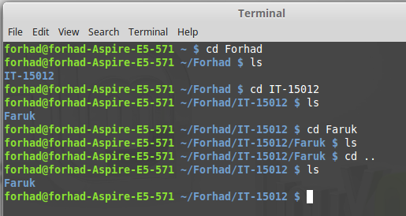

1. **cd ../ ../ :** It moves two directories up (and so on)

**Basic syntax:** cd ../ ../

**Output:**

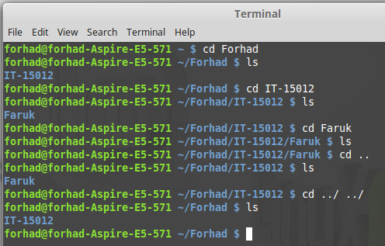

1. **ls :** It displays the list of files in the current working directory

**Basic syntax:** ls

**Output:**

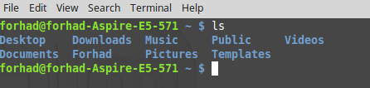

1. **mkdir <dir_name>:**It creates a directory with specified 'dir_name'.

**Basic syntax:** mkdir Forhad

**Output:**

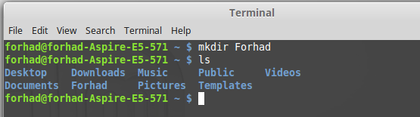

1. **mv <name1> <name2>:** It renames the directories or files.

**Basic syntax:** mv Akash Alif

**Output:**

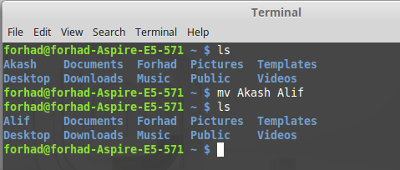

1. **cp <name> <path> :** It copies file/directory as specified in path

**Basic syntax:** cp File.txt Alif

**Output:**

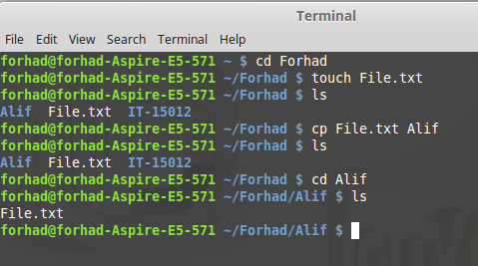

1. **rmdir <dir_name> :** It removes entire directory.

**Basic syntax:** rmdir Alif

**Output:**

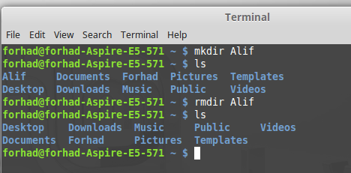

1. **rm <file_name> :** It removes file name.

**Basic syntax:** rm File.txt

**Output:**

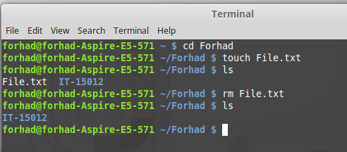

1. **rm ­r < dir_name>:** It removes directory including it's contents.

**Basic syntax:** rm –r Alif

**Output:**

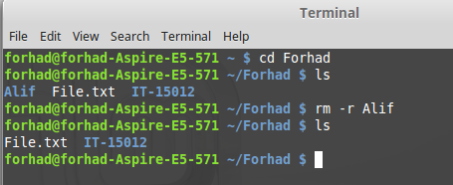

1. **mv <name> <path>:** It moves files/directories to the specified path.

**Basic syntax:** mv Alif ~/Forhad

**Output:**

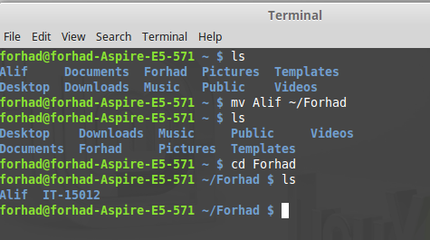

**Conclusion:** In this lab, we have to learn about how to working procedure of basic linux command. We have successfully done it with basic linux command. It helps us to make more efficient of the future in Linux operating system.